Build a Employee Travel Approval Application for Corporates

**Project Report Template**

**INTRODUCTION**

1. Overview

Travel approval means **approval of official travel in advance by an appropriately delegated officer, utilising the appropriate form or system.**

1. Purpose

Travel request forms are designed **to give management an overview of the intended business trip from both a cost and a strategic point of view**. The fields that typically appear on a travel request form include; Employee name and contact information

**Problem Definition & Design Thinking**

**1. Empathy Map**

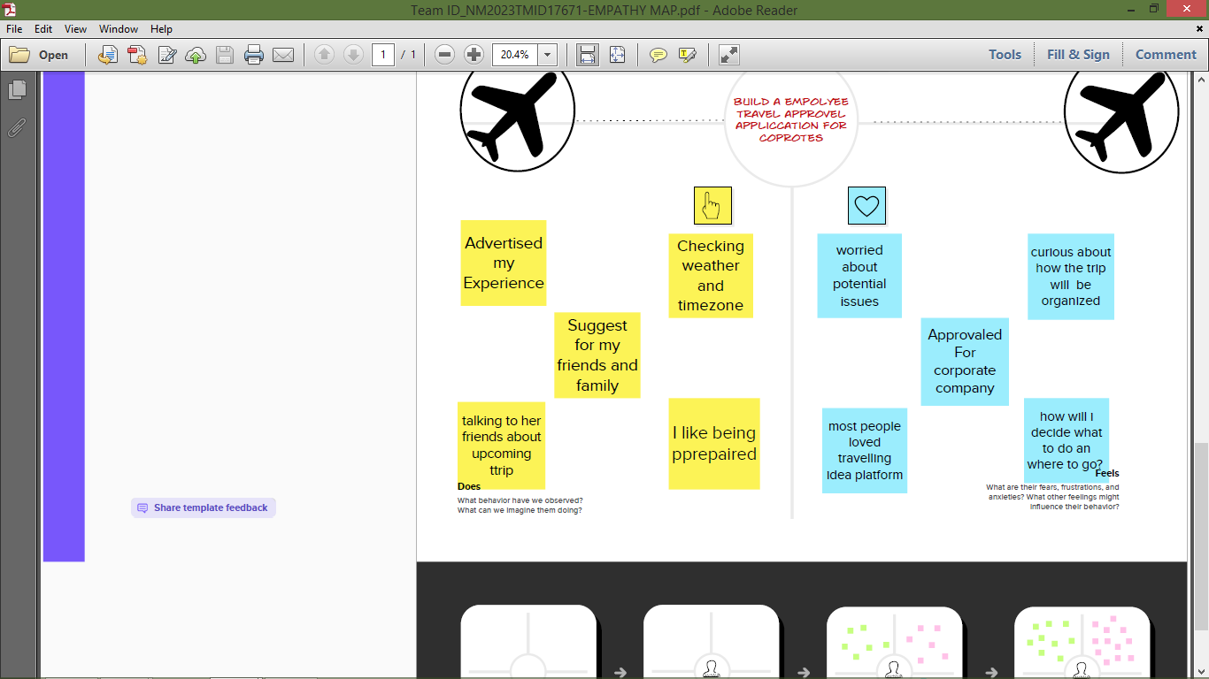

2. Ideation & Brainstorming Map

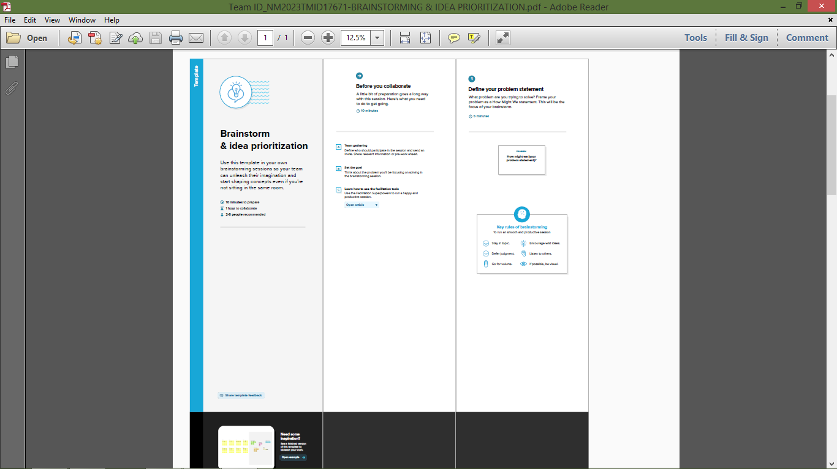

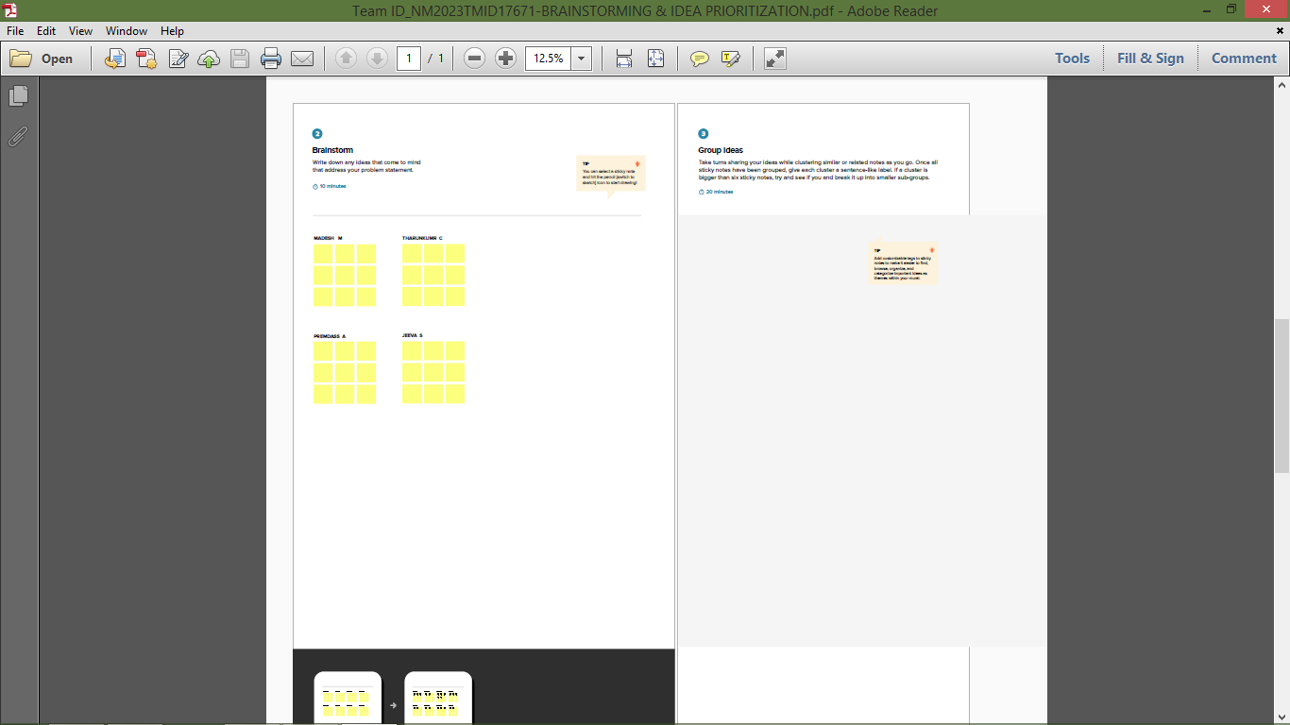

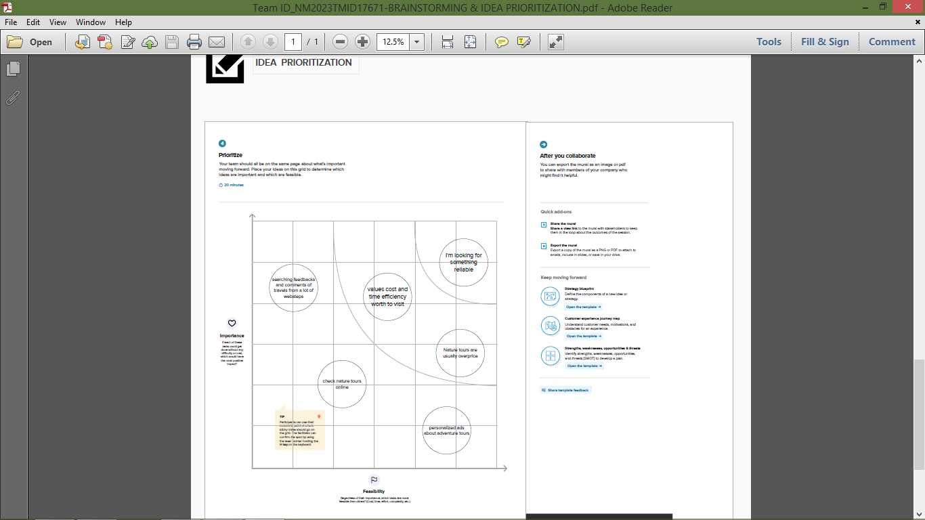

RESULT

1 Data Model:

|  |  |
| --- | --- |
| Object name | Fields in the Object |
| Department | |  |  | | --- | --- | | Field label | Data type | | Department | **Text** | |
| Travel approval | |  |  | | --- | --- | | Field label | Data type | | Travel approval | Auto Number | |
| Expense Item | |  |  | | --- | --- | | Field label | Data type | | Expense Item | Auto Number | |

Activity & Screenshot

**Create The Travel Application:**

### Custom Object Creation:

### 1. Department   Project Completed :

### Trailhead Profile Public URL

### Team Leader - <https://trailblazer.me/id/madem16>

### Team Member 1 –https://trailblazer.me/id/prem43

### Team Member 2 –https://trailblazer.me/id/tharc7

### Team Member 3 –

### Project Report Template

### ADVANTAGES & DISADVANTAGE:

### ADVANTAGES:

* It's a low cost way to list your property and its rooms.
* Reductions in your online marketing spend. OTAs will invest in marketing and advertising to attract potential international customers.
* A reduction in your website costs. OTAs are keen to provide a positive online experience for customers through good website design and functionality.
* Online travel websites are popular with customers who like to compare accommodation costs and the services offered by individual providers.
* Impartial reviews on online travel websites may give new customers the confidence to book.

### 

### DISADVANTAGE:

* Online travel agents can charge commission on every sale. This can range between 10-25% of the gross cost.
* There may be restrictive terms and conditions imposed by OTAs such as guest cancellation and automatic room reselling policies.
* You may need to find a way of managing room availability across a range of OTAs, your own website, front desk and telephone sales. This can be time consuming and labour intensive. There are software options to help you manage this.
* Using OTAs does not reduce the need to have your own website with booking engine.
* You may still need to invest in a balanced multi-channel marketing strategy.

### Project Report Template

### ADVANTAGES & DISADVANTAGE:

### ADVANTAGES:

* It's a low cost way to list your property and its rooms.
* Reductions in your online marketing spend. OTAs will invest in marketing and advertising to attract potential international customers.
* A reduction in your website costs. OTAs are keen to provide a positive online experience for customers through good website design and functionality.
* Online travel websites are popular with customers who like to compare accommodation costs and the services offered by individual providers.
* Impartial reviews on online travel websites may give new customers the confidence to book.

### 

### DISADVANTAGE:

* Online travel agents can charge commission on every sale. This can range between 10-25% of the gross cost.
* There may be restrictive terms and conditions imposed by OTAs such as guest cancellation and automatic room reselling policies.
* You may need to find a way of managing room availability across a range of OTAs, your own website, front desk and telephone sales. This can be time consuming and labour intensive. There are software options to help you manage this.
* Using OTAs does not reduce the need to have your own website with booking engine.
* You may still need to invest in a balanced multi-channel marketing strategy.

APPLICATIONS

### Creating Developer Account

### Account Activation

### Create The Travel Application

### Create The Travel Application

**Create 3 custom objects and tabs**

a) Department

b) Travel Approval

c) Expense Item

### Create A Custom Tab

### Create - Fields& Relationships

### Create The Expense Type Field.

### Create The Travel Approval Field.

### Import Departments

* + Create Salesforce Org
    - Creating Developer Account
    - Account Activation
  + Creating The Application
    - Create The Travel Application
  + What Is An Object
    - Custom Object Creation
    - Create 3 Custom Objects And Tabs
  + What Is A Tab
    - Create A Custom Tab
  + Create - Fields& Relationships
    - Create Fields & Relationships
    - Create The Expense Type Field.
    - Create The Travel Approval Field.
  + Import Departments
    - Import Departments
  + Customize User Interface
    - Create User And Setup Approvals
  + Use Customization
    - Customize Travel Approval Object Page Layout
  + Add Business Logic To Travel App
    - Create Validation Rule
    - Create RollUp Summary Fields
    - Create Formula Fields
  + What Are Reports
  + Dashboards

### CONCLUSION

Travel approvel application was very usefull for my life and how to create in travel approvel app in learned . Thank you for this program .

Its use full for feature life.

### FUTURE SCOPE

Travel and Tourism field involves **hospitality management, tour management, travel management etc**. It has endless job opportunities in India as large number of heritage, cultural and other tourists throng the country every year.

### THE END………